Pc Builders App - Builders HQ

Screens

Home Page

1: Example Builds: Community App - Variety of Cards – touchable opacity - take you to Screen with information

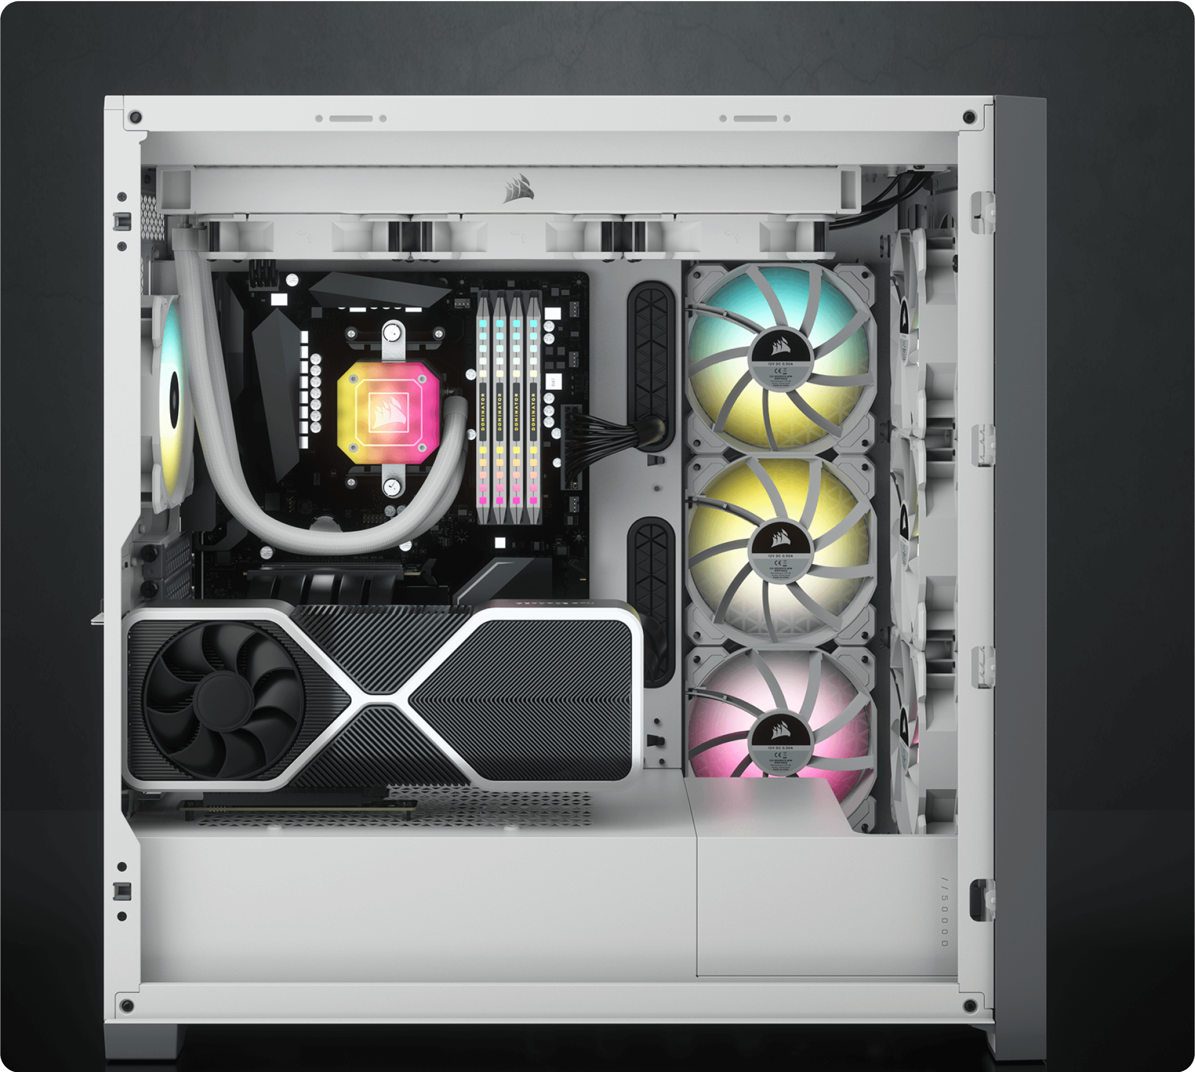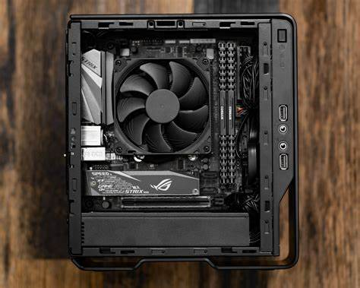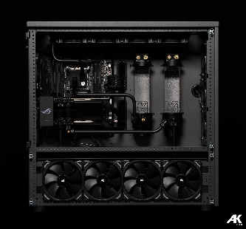 Images:

ITX simplisitic build

All black Liquid cooled pc build, atx

Overkill white pc build

2: How To Build your own PC – Detailed steps on how to build your PC – what you need – Procedures etc.

Tools Needed:

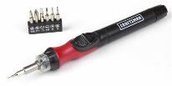

Screw Driver



Flash Drive (For your OS e.g. Windows 11)

Parts:

* Case: This is the component that holds all of the parts to make up the computer system.
* Motherboard: The main circuit board that connects all the components.
* Central Processing Unit (CPU): The brain of the computer that does the bulk of the thinking.
* Random Access Memory (RAM): The temporary memory that the computer uses to store data.
* Graphics Card or Graphics Processing Unit (GPU): The component that processes and displays graphics.
* Sound Card: The component that processes and outputs sound.
* Hard Disk Drive (HDD): The component that stores data on spinning disks.
* Solid State Drive (SSD): The component that stores data on flash memory chips.
* Power Supply Unit (PSU): The component that provides power to the other components.
* Cooling: The components that keep the system cool, such as fans and heatsinks.

